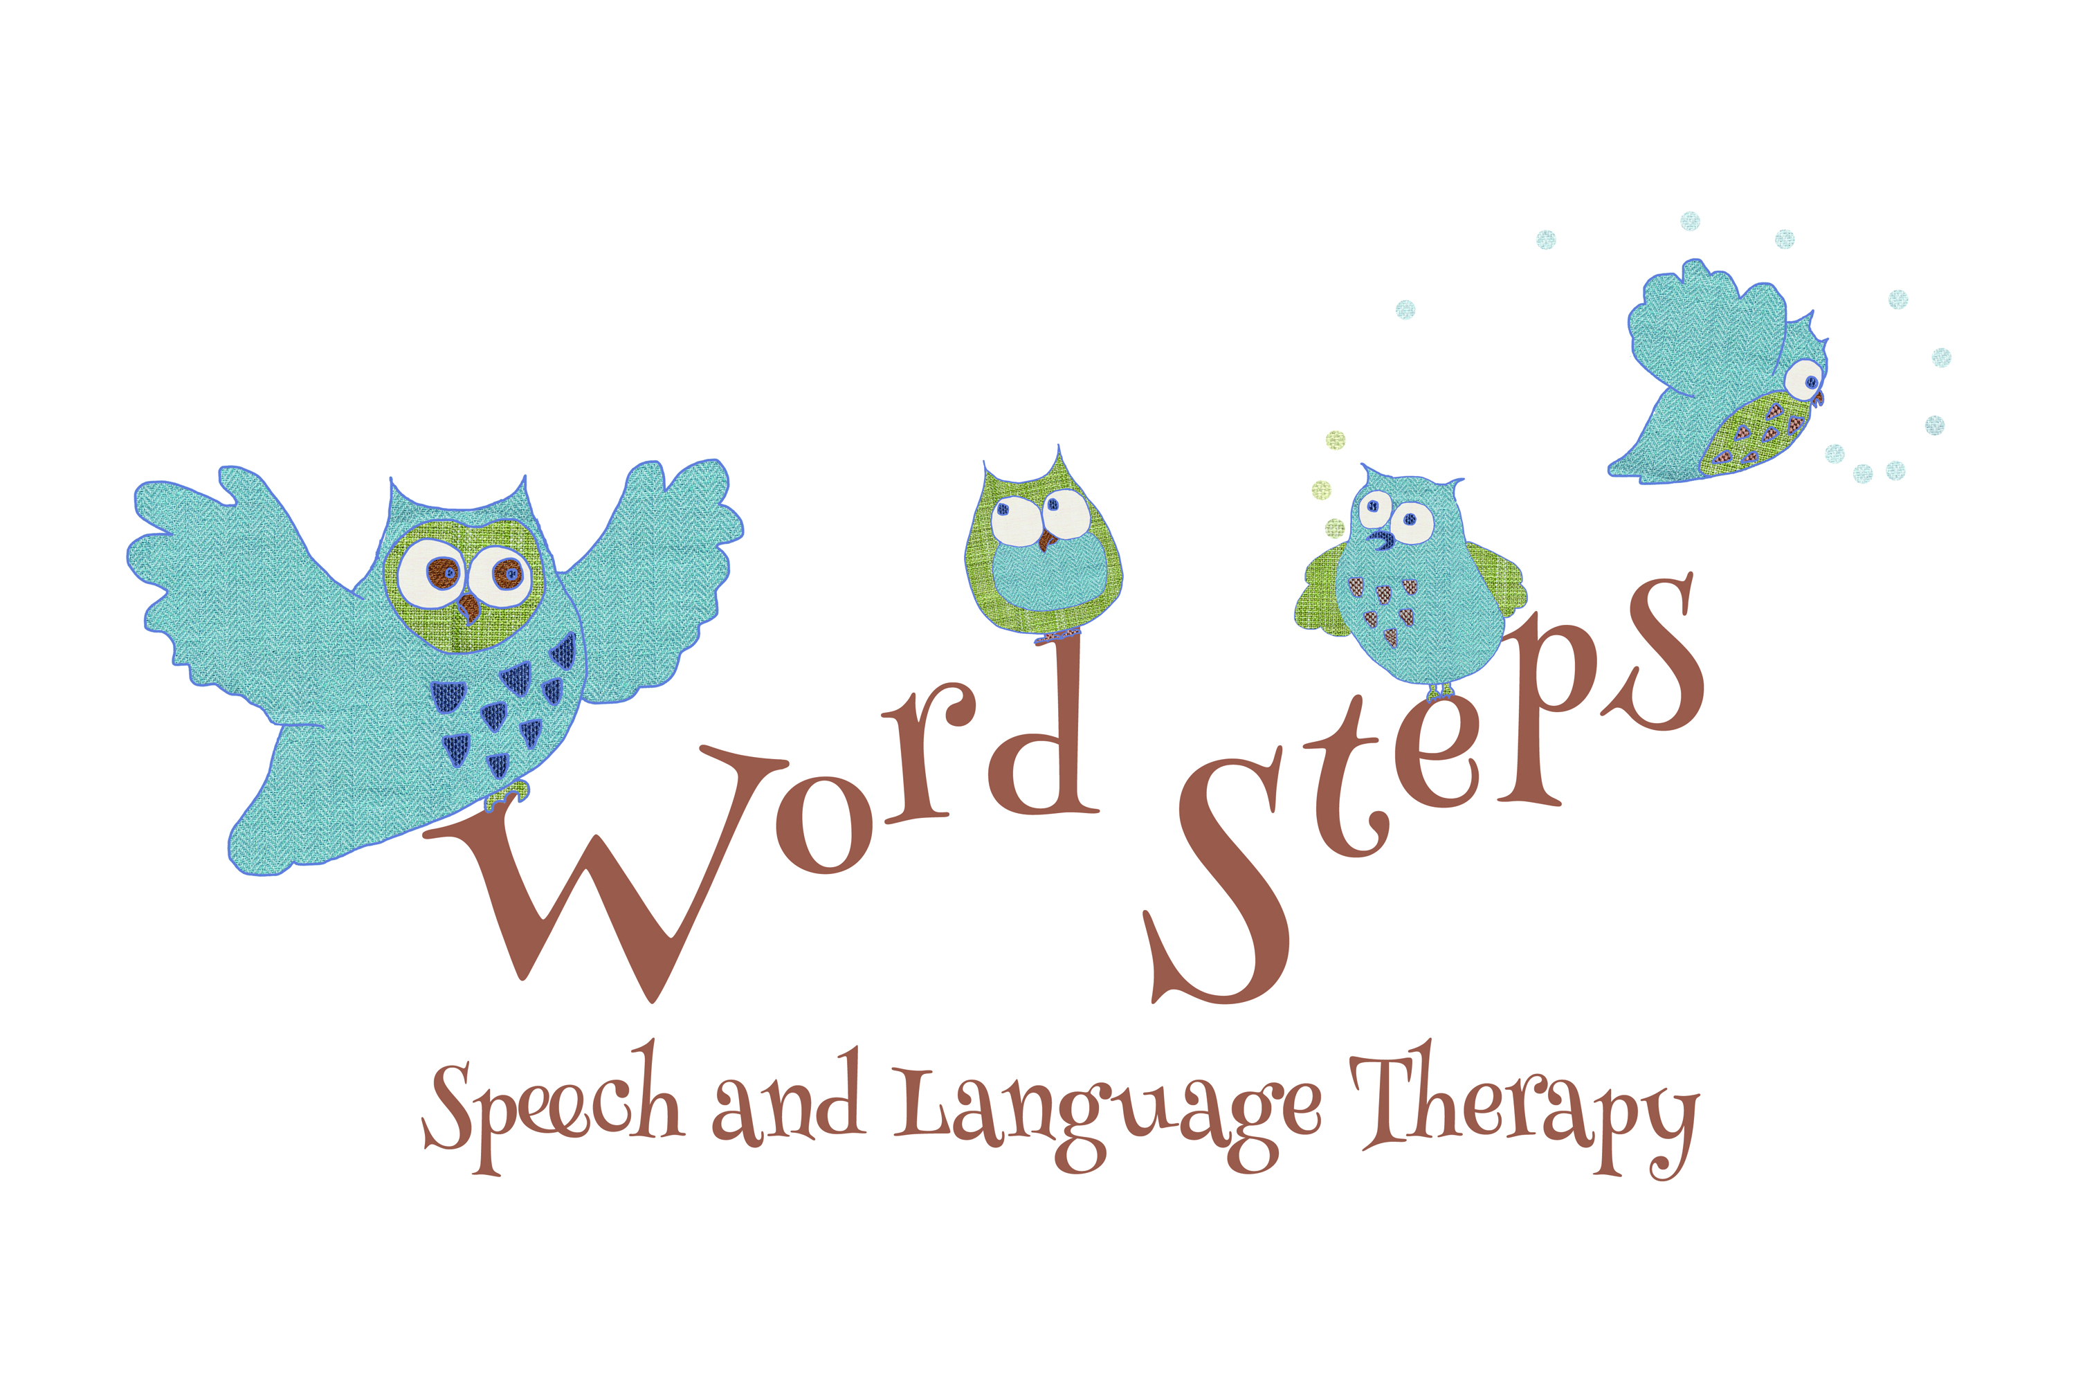
DATA PROTECTION PRIVACY NOTICE

Word Steps Speech Therapy complies with the General Data Protection Regulation (GDPR) and is committed to protecting your personal information. This policy describes our procedures for ensuring that personal information about young people and their families is processed fairly and lawfully. It contains important information about what personal details we collect, what we do with the information, who we may share it with and why; and your choices and rights when it comes to the personal information you have given us.
We may need to make changes to this Privacy Policy in the future and will inform you of any important changes. Word Steps is registered with the Information Commissioner’s office and the data controller/processor. You can view my ICO registration by visiting: www.ico.org.uk/ESDWebPages/Entry/ZA298073

What data does Word Steps hold?
To provide your child with a meaningful and high standard of care and attention, Word Steps requires to hold accurate personal information about your child.
Only personal information which is relevant to the care, support and treatment of the young person and their family will be obtained and only with parental / carer consent. The type of information we hold would include:
- Date of birth of the Young Person
- Address of the Young Person’s Home
- Home Telephone & Parental Mobile Telephone Numbers
- Parental Email Addresses
- Name of GP Surgery
- Name of Educational Establishment
- Relevant Medical Diagnosis & Development History
- Liaison Agreement Consent Forms
- Treatment Goals & Treatment Notes
- Email Correspondence from other Healthcare and Educational Professionals
- Written Reports, Child Plans & Minutes from Inter-Disciplinary Meetings
- A record of a session includes a brief description of the activities carried out, how the child performed in each of the activities, a summary of any discussions that took place and a plan of action for what will happen next
- Any phone calls or conversations that occur outside of the face to face sessions are also recorded in the case notes.

Sources of Personal Information
Personal Information about your child is obtained initially from you, the parent/carer, either verbally or through written means e.g. email, Short Message Service (text message), WhatsApp or Facebook Messenger.
Only with your parental / carer consent would information from other professionals working with your child (e.g. teacher, pupil support workers, occupational therapist, NHS speech & language therapists) be sought.

Why does Word Steps hold this personal data?
Word Steps holds contact data in order to communicate with clients and their carers to arrange sessions and share information relevant to the case.
- A case history is essential for understanding the nature of a communication difficulty and so that effective assessment can lead to an accurate diagnosis.
- Case notes form a record of the client’s progress and allow future therapy to be planned in as an effective and efficient way possible.
- Data is also used by Word Steps for the purpose of keeping our own accounts and records in accordance with the requirements of Her Majesty’s Revenue Custom’s and the Information Commissioner’s Office.

Sharing of Personal Information
Your information is only ever shared when you have given written consent for this to happen.
- The reason for sharing information and who it will be shared with will be explained to you at the time so that your consent is informed. Any information sharing is carried out with the client’s best interests in mind and typically takes the form of specific information about your child’s communication issue, for example, copying speech & language reports to other professionals your child sees, giving written strategies to help others to support your child or case discussions with other professionals.
- Only with your parental / carer consent would Word Steps submit verbal or written reports to other professionals pertaining to your child’s speech and language therapy support. If given, the dated and signed Consent Form will be included within your child’s casenotes.
- Unless Word Steps is required to by law, we will not disclose any personal information relating to your child to persons unnamed on the Consent Form.
- Word Steps does not employ agents to process personal data, for example, specialist mailing companies to send out communications, nor do we give or sell client details to any third parties.

Where is my data kept?
Your information is held in paper files at the Word Steps Speech & Language Therapy business address. These files are kept in locked filing cabinets. Electronic data is kept to a minimum and is stored on our password protected computers & offline external hard drive. Videos and audio-recordings will only be taken of your child with parental / carer consent. These recordings will be stored on an encrypted and password protected tablet.

What is your Lawful Basis for keeping my data?
- Data protection legislation requires businesses to make clear the ‘Lawful Basis’ for retaining your data. This basically means businesses have to tell you the reason why they need your data.
- These reasons are defined by the regulations and the reason your data is collected can vary over time.

In the case of Word Steps, data is kept under the following legal bases:
- Contract’ - in most cases, your data is collected as part of our contract to provide you with a
quality Speech & Language Therapy Service. We need to keep a record of the presenting
problem, steps taken to address it and the effectiveness of therapy provided.
- ‘Consent’ - by signing below, you will have given your consent for your data to be used
specifically by Word Steps to provide speech and language therapy support for your child.
- ‘Legal Obligation’ - any data collected by Word Steps may be subject to a legal obligation. For example, case notes must be retained for the periods defined by law (see below).

How Long will you store my data?
If you make an enquiry, do not have any face to face sessions and no further action is required, your data is deleted within a month of your first contact. If you have one or more face to face sessions then a case file is opened. Once the client is discharged, the paper case records are stored in locked file boxes in accordance with the legal requirements for medical records before they are shredded at the end of the required retention period. The law says that Children's records must be kept:
• Until the child is 25 (or 26 if they are 17 when treatment ends) or eight years after their death, if
sooner.
• If the child's illness could be relevant to an adult condition or have genetic implications for their
family, records must be kept until the client’s death.

Can I get Access to my data?
Yes, you can as long as you are an entitled person, i.e. either the client or someone with legal
responsibility for the client. Email Anna Biavati-Smith at wordstepsslt@gmail.com.

Can I withdraw my consent or ask for my data to be deleted?
You can withdraw your consent at any time by email to wordstepsslt@gmail.com.. Any data that does not have to be retained legally as part of your case notes can also be destroyed if you so wish.

Your Rights
Your key rights, as a parent/ carer, that will be protected by GDPR are as follows:
- The right to be informed
- The right to access
- The right to rectification
- The right to erasure
- The right to restrict processing
- The right to data portability
- The right to object
- The right not to be subject to automated decision-making including profiling
For further information, visit www.ico.org.uk/for-the-public/is-my-information-being-handled-correctly.

What happens if there is a data breach?
In the unlikely event that someone unauthorised accesses the data Word Steps holds, you will be informed of the breach and the steps taken to address it. Any breach will be reported to the Information Commissioners Office in accordance with the law.

Can I make a complaint if I have concerns about the way Word Steps handles my data?
Yes you can. If you have concerns about how your data is being handled by Word Steps, you are welcome to contact us directly in writing to Anna Biavati-Smith at wordstepsslt@gmail.com.
If we cannot resolve your concern, you also have the right to pass your concerns on to the Information Commissioner’s Office via the website at https://ico.org.uk/global/contact-us/ or at the following contact details: Information Commissioner's Office, 45 Melville Street, Edinburgh, EH3 7HL, Tel: 0303 123 1115, email: scotland@ico.org.uk

How can I let Word Steps know who I’m happy to share data with?
Consulting with other professionals is key to providing a high quality service for your child. Please fill in the professional’s name then tick and initial to indicate the who you are willing for Word Steps to share information with, in written or spoken form:

Other Speech & Language Therapist(s)
Occupational Therapist
Physiotherapist
Consultant Paediatrician
GP
Health Visitor
Educational Psychologist
Your child's teacher
Education staff other than your child’s teacher (eg Teaching assistant, ASL staff)
Other (please specify)

Please tick to indicate which methods of communication you are happy for Blethers Speech &
Language Therapy to use in order to contact you:

Written letter
Land line phone call
Mobile phone call
Text (SMS) message
Encrypted messaging service such as What’sApp
Email - Please give email address:

I have read and understood this Data Protection Policy and consent to Word Steps Speech &
Language Therapy processing my information in this manner for the purposes stated in the Policy:

Signed: Date:

Print name: Relationship to Child:

Please do ask any questions you have before you sign and remember you can withdraw
consent at any time if you want to.

